Bash Scripting

Introduction
This document contains practical Bash scripts covering common Linux and DevOps administration tasks such as directory validation, file creation, backups, service management, EC2 software installation, file manipulation, and system resource monitoring.
The EC2 installation examples assume Amazon Linux 2023. Commands may need minor adjustments for Ubuntu or other Linux distributions.

1. Check if a Directory is Available
Checks whether the specified path exists and is a directory.

Bash Script
#!/bin/bash
DIR="/opt/app"
if [ -d "$DIR" ]; then
echo "Directory exists: $DIR"
else
echo "Directory does not exist: $DIR"
fi

How to Run
chmod +x dir.bash
./dir.bash

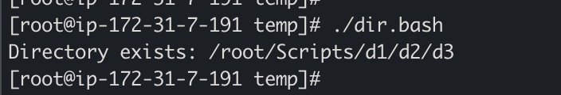

DevOps Real-Time Use Case
Useful before deploying an application, writing logs, or copying configuration files into a known directory.

2. Create Multiple Files
Creates a directory if required and then creates five files using a Bash for loop.

Bash Script
#!/bin/bash
DIR="/tmp/myfiles"
mkdir -p "$DIR"
for i in {1..5}
do
touch "$DIR/file$i.txt"
echo "Created: $DIR/file$i.txt"
done
echo "All files created successfully."

How to Run
chmod +x create_multiple_files.bash
./create_multiple_files.bash

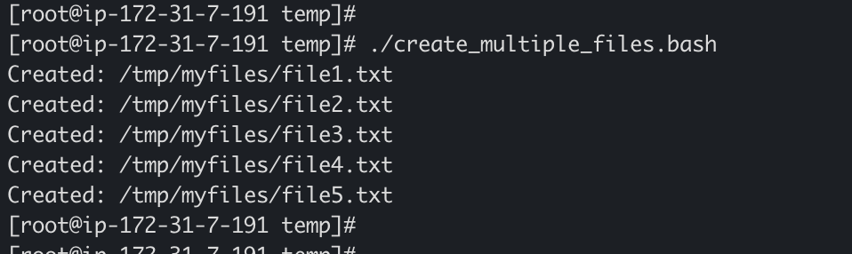

DevOps Real-Time Use Case
Useful for creating application placeholders, test files, configuration templates, or log files during automation.

3. Take Backup of a Directory
Creates a timestamped compressed tar.gz archive of the source directory.

Bash Script
#!/bin/bash
SOURCE_DIR="/root/Scripts/temp"
BACKUP_DIR="/root/Scripts/backup"
DATE=$(date +%Y%m%d_%H%M%S)
dir_name=$(basename "$SOURCE_DIR")
BACKUP_NAME="${dir_name}_backup_$DATE.tar.gz"
if [ -d "$BACKUP_DIR" ]; then
echo "Backup dir exist"
else
mkdir -p "$BACKUP_DIR"
fi
tar -czf "$BACKUP_DIR/$BACKUP_NAME" "$SOURCE_DIR"
if [ $? -eq 0 ]; then
echo "Backup created successfully: $BACKUP_DIR/$BACKUP_NAME"
else
echo "Backup failed!"
exit 1
fi
# Optional: Remove backups older than 30 days
find "$BACKUP_DIR" -name "backup_*.tar.gz" -mtime +30 -delete

How to Run
chmod +x backup_dir.bash
./backup_dir.bash

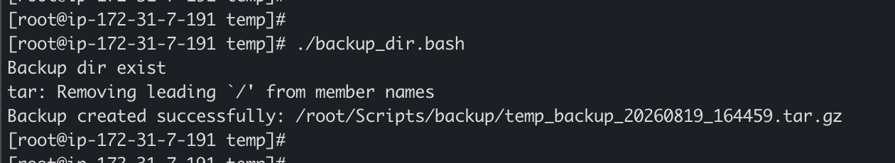

DevOps Real-Time Use Case
Before deploying a new application version, a DevOps engineer can back up the current web application directory and use the archive for rollback if needed.

4. Install Nginx in an EC2 Server
Installs Nginx on Amazon Linux 2023, starts the service, and enables it to start automatically after reboot.

Bash Script
#!/bin/bash
echo "Updating packages..."
sudo dnf update -y
echo "Installing Nginx..."
sudo dnf install nginx -y
echo "Starting Nginx..."
sudo systemctl start nginx
echo "Enabling Nginx at boot..."
sudo systemctl enable nginx
echo "Checking Nginx status..."
sudo systemctl status nginx --no-pager
echo "Nginx installation completed."

How to Run
chmod +x nginx.bash
./nginx.bash

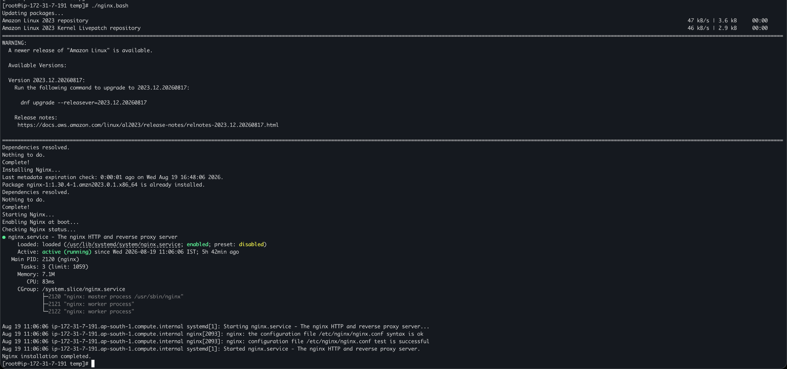

DevOps Real-Time Use Case
After installation, allow inbound TCP port 80 in the EC2 Security Group if the web server must be reachable from the internet.

5. Install Apache Tomcat in an EC2 Server
Installs Java, creates a dedicated Tomcat user, downloads Tomcat, configures permissions, creates a systemd service, and starts Tomcat.

Bash Script
#!/bin/bash
set -e
TOMCAT_VERSION="11.0.24"
TOMCAT_USER="tomcat"
TOMCAT_DIR="/opt/tomcat"
echo "Installing Java..."
sudo dnf install java-17-amazon-corretto -y
echo "Creating Tomcat user..."
sudo useradd -r -m -U -d "$TOMCAT_DIR" -s /bin/false "$TOMCAT_USER" || true
echo "Creating Tomcat directory..."
sudo mkdir -p "$TOMCAT_DIR"
echo "Downloading Apache Tomcat..."
cd /tmp
wget -q "https://dlcdn.apache.org/tomcat/tomcat-10/v${TOMCAT_VERSION}/bin/apache-tomcat-${TOMCAT_VERSION}.tar.gz" -O tomcat.tar.gz
echo "Extracting Tomcat..."
sudo tar -xzf tomcat.tar.gz --strip-components=1 -C "$TOMCAT_DIR"
echo "Setting permissions..."
sudo chown -R "$TOMCAT_USER:$TOMCAT_USER" "$TOMCAT_DIR"
sudo chmod +x "$TOMCAT_DIR/bin/"*.bash
echo "Creating systemd service..."
sudo tee /etc/systemd/system/tomcat.service > /dev/null <<EOF
[Unit]
Description=Apache Tomcat
After=network.target
[Service]
Type=forking
User=$TOMCAT_USER
Group=$TOMCAT_USER
Environment="JAVA_HOME=/usr/lib/jvm/java-17-amazon-corretto"
Environment="CATALINA_HOME=$TOMCAT_DIR"
Environment="CATALINA_BASE=$TOMCAT_DIR"
ExecStart=$TOMCAT_DIR/bin/startup.bash
ExecStop=$TOMCAT_DIR/bin/shutdown.bash
Restart=on-failure
[Install]
WantedBy=multi-user.target
EOF
echo "Reloading systemd..."
sudo systemctl daemon-reload
echo "Starting Tomcat..."
sudo systemctl start tomcat
echo "Enabling Tomcat at boot..."
sudo systemctl enable tomcat
echo "Checking Tomcat status..."
sudo systemctl status tomcat --no-pager
echo "Tomcat installation completed."

How to Run
chmod +x apache1.bash
./apache1.bash

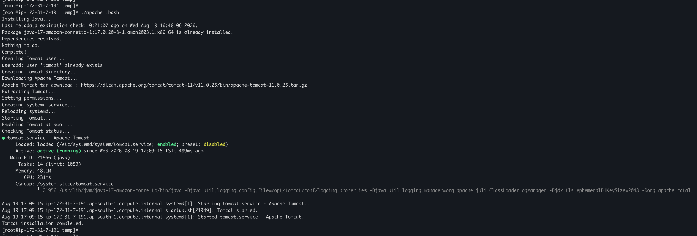

DevOps Real-Time Use Case
Tomcat commonly listens on port 8080. Allow TCP 8080 in the EC2 Security Group only when direct external access is required. Tomcat versions change, so update TOMCAT_VERSION when necessary.

6. Check Nginx Service and Start It if Not Running
Checks Nginx service health and starts it automatically when it is stopped.

Bash Script
#!/bin/bash
SERVICE="nginx"
if systemctl is-active --quiet "$SERVICE"
then
echo "$SERVICE is running."
else
echo "$SERVICE is not running."
echo "Starting $SERVICE..."
sudo systemctl start "$SERVICE"
if systemctl is-active --quiet "$SERVICE"
then
echo "$SERVICE started successfully."
else
echo "Failed to start $SERVICE."
exit 1
fi
fi

How to Run
chmod +x check_nginx.bash
./check_nginx.bash

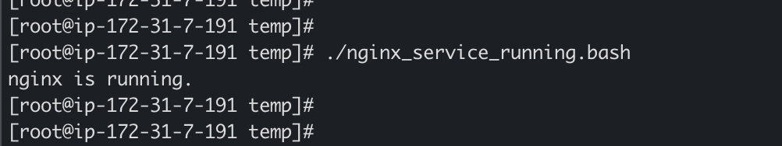

DevOps Real-Time Use Case
This pattern is useful for basic service self-healing automation and can be scheduled using cron.

7. Check a Directory and Create It if Missing
Checks whether the directory exists and creates the complete directory structure when it does not.

Bash Script
#!/bin/bash
DIRECTORY="/root/Scripts/temp"
if [ -d "$DIRECTORY" ]; then
echo "Directory $DIRECTORY already exists."
else
echo "Directory $DIRECTORY does not exist. Creating now..."
mkdir -p "$DIRECTORY"
echo "Directory created successfully!"
# Optionally set permissions
chmod 755 "$DIRECTORY"
fi

How to Run
chmod +x direxist.bash
./direxist.bash

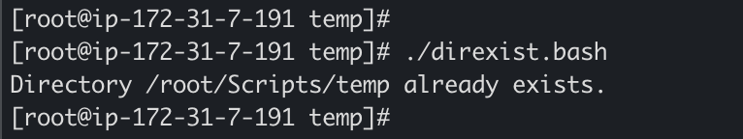

DevOps Real-Time Use Case
Useful in deployment scripts before creating application logs, uploads, reports, temporary files, or configuration directories.

8. Delete the Last 3 Lines from a File
Removes the final three lines after validating that the target file exists and contains at least three lines.

Bash Script
#!/bin/bash
FILE="/root/Scripts/error.txt"
if [ ! -f "$FILE" ]; then
echo "File does not exist!"
exit 1
fi
# Get total lines
TOTAL_LINES=$(wc -l < "$FILE")
# Check if file has at least 3 lines
if [ $TOTAL_LINES -lt 3 ]; then
echo "File has less than 3 lines. Cannot delete the last 3 lines."
exit 1
fi
# Delete last 3 lines
LINES_TO_KEEP=$((TOTAL_LINES - 3))
head -n $LINES_TO_KEEP "$FILE" > temp_file
mv temp_file "$FILE"
echo "Last 3 lines deleted successfully!"
echo "Original lines: $TOTAL_LINES, Current lines: $(wc -l < "$FILE")"

How to Run
chmod +x delete_last_3lines.bash
./delete_last_3lines.bash

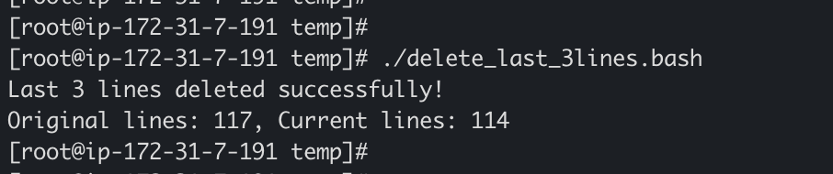

DevOps Real-Time Use Case
Because the original file is modified, create a backup first in production environments, for example: cp "$FILE" "$FILE.bak".

9. Monitor CPU Usage and Send Email if Above 80%
Reads CPU utilization and sends an email when usage exceeds the configured threshold.

Bash Script
#!/bin/bash
THRESHOLD=5
EMAIL="nayeemabdul@hotmail.com"
CPU_USAGE=$(top -bn1 | grep "Cpu(s)" | awk '{print 100 - $8}')
CPU_USAGE_INT=${CPU_USAGE%.*}
echo "Current CPU Usage: $CPU_USAGE%"
if [ "$CPU_USAGE_INT" -gt "$THRESHOLD" ]
then
SUBJECT="ALERT: High CPU Usage on $(hostname)"
MESSAGE="CPU usage on $(hostname) is currently ${CPU_USAGE}%.
Threshold: ${THRESHOLD}%"
echo "$MESSAGE" | mail -s "$SUBJECT" "$EMAIL"
echo "CPU alert email sent."
else
echo "CPU usage is normal."
fi

How to Run
chmod +x monitor_cpu.bash
./monitor_cpu.bash

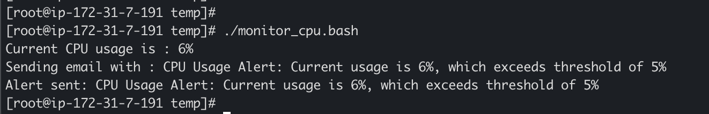

DevOps Real-Time Use Case
A working mail/SMTP configuration is required for the email to reach an external mailbox. This script is suitable as a learning example and can be scheduled with cron.

10. Monitor Disk Space and Send Email if Above 80%
Checks disk utilization for the root filesystem and sends an alert when it exceeds 80%.

Bash Script
#!/bin/bash
THRESHOLD=15
EMAIL="nayeemabdul@hotmail.com"
DISK_USAGE=$(df -P / | awk 'NR==2 {print $5}' | tr -d '%')
echo "Current Disk Usage: ${DISK_USAGE}%"
if [ "$DISK_USAGE" -gt "$THRESHOLD" ]
then
SUBJECT="ALERT: High Disk Usage on $(hostname)"
MESSAGE="Disk usage on $(hostname) is ${DISK_USAGE}%.
Threshold: ${THRESHOLD}%"
echo "$MESSAGE" | mail -s "$SUBJECT" "$EMAIL"
echo "Disk usage alert email sent."
else
echo "Disk usage is normal."
fi

How to Run
chmod +x monitor_disk.bash
./monitor_disk.bash

DevOps Real-Time Use Case
In production, consider monitoring each important mounted filesystem rather than only /, depending on the server architecture.

11. Monitor Memory Usage and Send Email if Above 80%
Calculates memory utilization and sends an email when it exceeds 80%.

Bash Script
#!/bin/bash
THRESHOLD=20
EMAIL="nayeemabdul@hotmail.com"
# Get memory usage percentage
MEMORY_USAGE=$(free | grep Mem | awk '{print ($3/$2) * 100.0}' | cut -d. -f1)
if [ $MEMORY_USAGE -gt $THRESHOLD ]; then
MESSAGE="Memory Usage Alert: Current usage is $MEMORY_USAGE%, which exceeds threshold of $THRESHOLD%"
# Get detailed memory info
DETAILS=$(free -h)
# Get top memory consuming processes
PROCESSES=$(ps aux --sort=-%mem | head -10)
# Send email notification
echo -e "$MESSAGE\n\nMemory Details:\n$DETAILS\n\nTop Memory Consuming Processes:\n$PROCESSES" | mail -s "High Memory Usage Alert" $EMAIL
# Also log to a file
echo "$(date): $MESSAGE" >> /var/log/memory_monitor.log
echo "Alert sent: $MESSAGE"
else
echo "Memory usage is within normal range: $MEMORY_USAGE%"
fi

How to Run
chmod +x memory_monitor.bash
./memory_monitor.bash

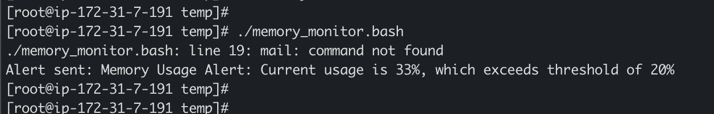

DevOps Real-Time Use Case
This is useful for identifying memory pressure before applications become unstable or the Linux OOM killer becomes involved.

Recommended Script Directory Structure
devops-scripts/
├── dir.bash
├── create_multiple_files.bash
├── backup_dir.bash
├── nginx.bash
├── apache1.bash
├── nginx_service_running..bash
├── direxist.bash
├── delete_last_3lines.bash
├── monitor_cpu.bash
├── monitor_disk.bash
└── memory_monitor_.bash
Make all scripts executable:
chmod +x *.bash

Scheduling Monitoring Scripts with Cron
The CPU, disk, and memory monitoring scripts can be combined into one system-monitoring script and scheduled with cron. For example, the following entry runs a monitoring script every five minutes:
*/5 * * * * /opt/scripts/system_monitor.bash
Cron-based monitoring is useful for learning and lightweight server automation. In larger production environments, dedicated monitoring and alerting platforms are generally preferred.

Common Bash Concepts Used
- -d – Checks whether a path exists and is a directory.
- -f – Checks whether a path exists and is a regular file.
- if / else – Performs conditional decision making.
- for – Repeats commands for a set of values.
- $? – Contains the exit status of the previous command.
- $(command) – Command substitution; captures command output.
- systemctl – Controls and checks systemd services.
- df – Reports filesystem disk-space usage.
- free – Reports memory usage.
- top – Provides process and CPU information.
- tar – Creates and extracts archive files.
- cron – Schedules commands or scripts to run automatically.

Production Best Practices
- Use set -euo pipefail carefully in production scripts where appropriate.
- Validate input variables and paths before performing destructive operations.
- Use absolute paths in automation scripts to avoid PATH-related issues.
- Log important script actions and failures.
- Create backups before modifying important files.
- Run services with dedicated, least-privileged users where possible.
- Avoid exposing unnecessary EC2 ports through Security Groups.
- Do not hard-code sensitive passwords, API keys, or credentials in scripts.
- Test scripts in a non-production environment before deployment.
- For email alerts, configure a reliable SMTP relay or approved notification service.

Quick Revision Summary
These scripts demonstrate core Bash skills frequently encountered in DevOps interviews and day-to-day Linux administration: file and directory tests, loops, variables, command substitution, exit-status handling, archive creation, package installation, systemd service management, resource monitoring, and basic alerting.

